**Understanding and Computing the Standardized**

**Precipitation Index**

*Karthik Reddy Pagilla*

*University of Nebraska-Lincoln*

**1. Introduction**

**1.1 Background**

A drought is a period of time when an area or a region experiences lower levels of precipitation from what is considered normal. When this phenomenon extends over a season or a long period of time, precipitation deficits can be devastating to human life, water resources, and economy and are commonly known as meteorological droughts (Yu et al., 2013). Meteorological drought is a natural disaster that can occur under all types of climatic regimes. Monitoring the drought is a vital factor in predicting and analyzing the impacts of droughts.

Over the years, many drought indices were developed and used by meteorologists and climatologists around the world. Droughts are regional in extent, and each region has specific climatic characteristics. So, droughts should be considered relative instead of absolute. Drought indices are calculated by a combination of climatic and meteorological variables, among which precipitation is the most important in defining the magnitude and intensity of a drought.

**1.2 Description of the Standardized precipitation index**

The Standardized Precipitation Index (SPI) was developed by McKee et al. (1993, 1995) as a widely used indicator to characterize meteorological drought, which standardizes the rainfall deficits/excess on a temporal and regional basis. SPI expresses the actual rainfall as a standardized departure with respect to rainfall probability distribution function permitting comparisons across space and time. Computation of SPI requires long term, typically 30-50 years of data on precipitation to determine the probability distribution function, which is then transformed to a normal distribution with a mean of zero and standard deviation of one.

McKee used the classification system shown in the table below (Table 1) to define the drought intensities using SPI. A drought event occurs any time the SPI is continuously negative and reaches an intensity of -1.0 or less. The event ends when the SPI becomes positive. Each drought event, therefore, has a duration defined by its beginning and end, and an intensity for each month that the event continues. The positive sum of the SPI for all the months within a drought event can be termed the drought’s “magnitude.”

The SPI was designed to quantify the precipitation deficit for multiple timescales. The timescales can be of any length, but McKee and others (1993) initially calculated the SPI for 3-, 6-,12-, 24- and 48-month timescales. Statistically, 1–24 months is the best practical range of application (Guttman, 1994, 1999).

**Table 1: SPI Classifications**

|  |  |
| --- | --- |
| **SPI Values** | **Conditions** |
| 2.0+ | Extremely wet |
| 1.5 to 1.99 | Very wet |
| 1.0 to 1.49 | Moderately wet |
| -0.99 to 0.99 | Near normal |
| -1.0 to -1.49 | Moderately dry |
| -1.5 to -1.99 | Very dry |
| -2 and less | Extremely dry |

**1.3 Interpretation of SPI at different time scales**

* **1-month SPI:** The one-month SPI reflects the short-term conditions like short-term soil moisture and crop stress. It is similar to the percentage of the normal precipitation over a 30-day period. The one-month SPI can be misleading with precipitation values less than the normal in regions with a small normal precipitation total for a month.
* **3-month SPI:** The 3-month SPI provides the comparison of the precipitation over a 3-month period with the precipitation totals over the same 3-month period. A 3-month SPI reflects short- and medium-term moisture conditions and provides a seasonal estimation of precipitation.
* **6-month SPI:** The 6-month SPI provides the comparison of the precipitation over a 6-month period with the precipitation totals over the same 6-month period. A 6-month SPI reflects seasonal and medium-terms in precipitation, and it can be very effective in showing the precipitation over distinct seasons.
* **9-month SPI:** The 9-month SPI provides the comparison of the precipitation over a 9-month period with the precipitation totals over the same 9-month period. The 9-month SPI provides an indication of inter-seasonal precipitation patterns over a medium-term duration.
* **12-month to 24-month SPI:** The SPI at these timescales reflects long-term precipitation patterns. SPIs of these timescales are usually tied to stream flows, reservoir levels, and even groundwater levels at these timescales.

**2. Data and Computational methodology**

**2.1 Data collection and extraction**

The rainfall data to compute the SPI is obtained from the Climate Hazards Group InfraRed Precipitation with Station data (CHIRPS) dataset. It is a 35+ year quasi-global daily rainfall data set. Spanning 50°S-50°N (and all longitudes) and ranging from 1981 to near-present with 0.05° resolution satellite imagery. CHIRPS incorporates in-situ station data to create gridded rainfall time series for trend analysis and seasonal drought monitoring. The gridded rainfall data is stored in the form of GeoTiff images.

This research study mainly focuses on four countries, namely India, Pakistan, Iraq, and Bangladesh and the time frame of 1989-2018 (30 years) is selected. The precipitation data for these countries should be extracted from the gridded global rainfall dataset using the shapefiles for the required countries. The algorithm given below can be used to extract the required precipitation data for specific countries from the global gridded dataset.

**Algorithm to clip GeoTiff images**

Input: GeoTiff image, and Shapefile,

Output: Clipped GeoTiff image,

1. Identify the no data value from G

2. Set the variable with the identified no data value

3. Clip G using S as a Mask into CG. // The clipping process can be done using GDAL

4. Return CG

Note: The ” command in the GDAL package can be used to clip raster files using a shapefile.

The clipped daily precipitation data for specified countries should then be aggregated to compute the monthly precipitation, and the monthly data for the 30 years should be aggregated into a single file to compute the SPI.

**2.2 Computational Methodology**

As pointed out by Guttman (1998, 1999), the first step in the calculation of the SPI is to determine a probability density function (pdf) that describes the long-term series of observations. Once this pdf is determined, the cumulative probability (cdf) of an observed precipitation amount is estimated. The standard inverse normal function, which has zero mean and unitary variance, is then applied to the cumulative probability resulting in the SPI.  Theoretically, the SPI is unbounded. Practically, however, the number of precipitation data, which is generally less than 100 for a given month, suggests bounds of -3.09 < SPI < 3.09.

Following Guttman (1999), a standard method, must be used for computing this drought index. If different pdf are used to describe an observed series of precipitation data, then different SPI values may be obtained. McKee et al. (1993), Hayes et al. (1999), Sansigolo (2004) and Blain (2005) used the 2-parameters gamma distribution (Gam) in SPI calculation. Guttmann (1999), analyzing the fit of several distributions to monthly precipitation series of the United States, recommends the Pearson type III distribution (PE3), as a universal model in SPI calculation.

The transformation of the precipitation value into standardized precipitation index has the purpose of:

a. Transforming the mean of the precipitation value adjusted to 0

b. The Standard deviation of the precipitation is adjusted to 1.0

c. The Skewness of the existing data has to be readjusted to zero

When these goals have been achieved the standardized precipitation index can be interpreted as mean 0 and standard deviation of 1.0

The Algorithm below can be used to compute the SPI values using the precipitation data.

**Algorithm to compute SPI**

Input: Precipitation dataset, where is the value of single precipitation

Output: Standardized Precipitation Index,

1. Compute the mean of the precipitation

// is the number of precipitation observations

2. Compute the standard deviation for the precipitation

3. Compute the skewness of the precipitation

4. The precipitation is converted to lognormal values

5. Compute statistics U

6. Compute shape parameter

7. Compute scale parameter

8. Compute the location parameter

9. Use the resulting parameters to fit the data through the probability density functions. Choose either Gamma distribution or Pearson III distribution

(or)

10. Compute the final cumulative probability,

// n is the total number of zeros

(or)

11. Apply the inverse normal (Gaussian) function, with mean zero and variance one, to the cumulative probabilities, and the result is SPI

2.515517

0.802853

0.010328

1.432788

0.189269

0.001308

for

for

for

for

12. Return SPI

**Note:**

1. Formula to compute :

2. Formula to compute :

3. Formula to compute

4. The values of c0, c1, c2, d1, d2, d3 given in Equation (A11) are constants being widely employed for SPI computation (Abramowitz and Stegun 1965).

**3. Results**

The SPI computations are shown for the four countries, India, Pakistan, Iraq, and Bangladesh, for the July rainfall of 2000. The timescales included in the SPI computation are 1, 3, 6, and 12. And the pdfs used to fit the data are both Gamma and Pearson III.



SPI Scale

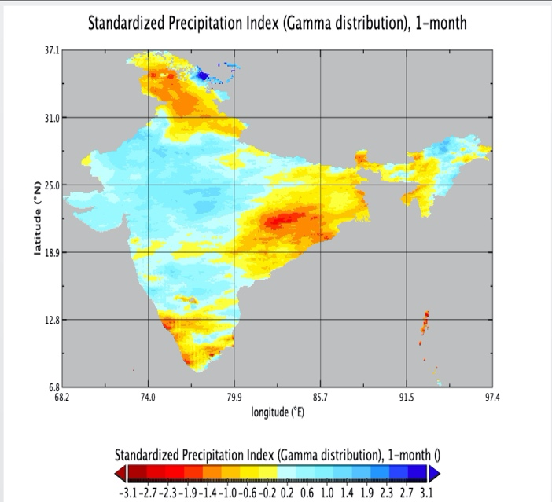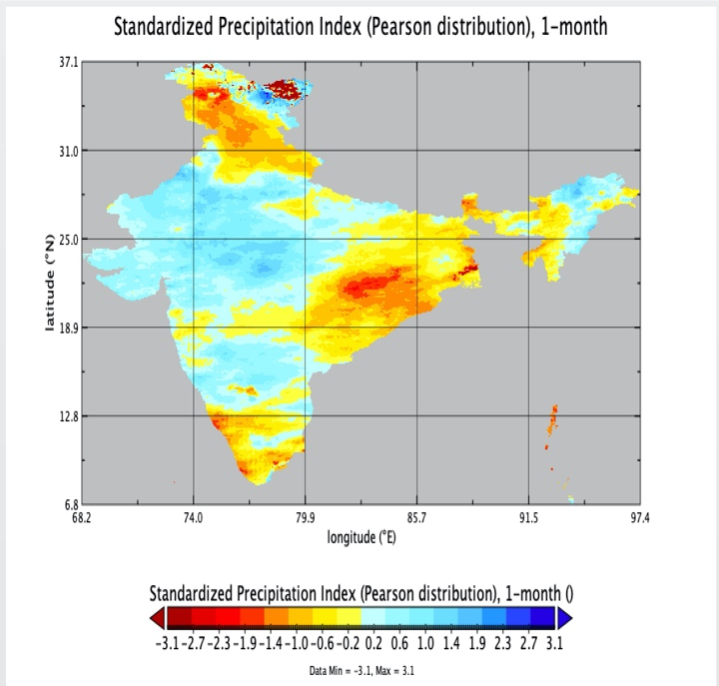

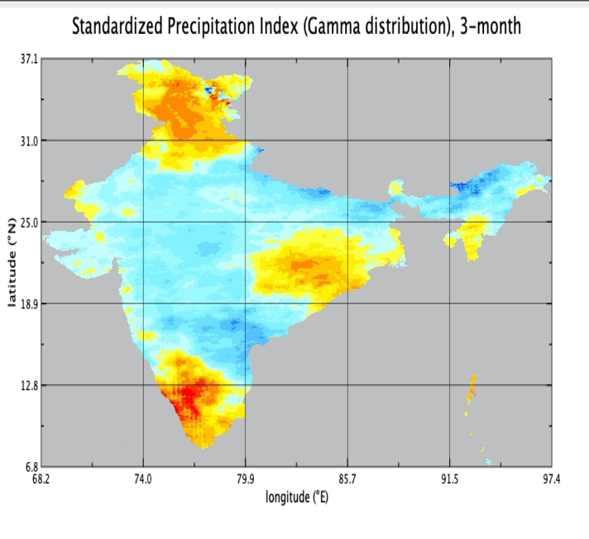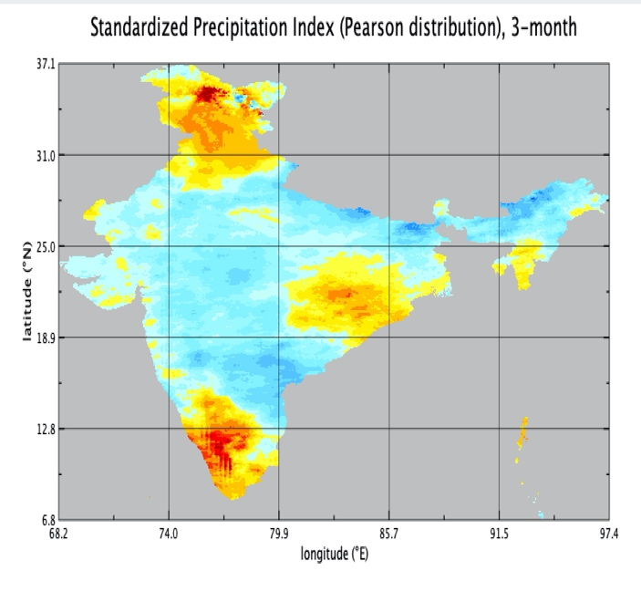

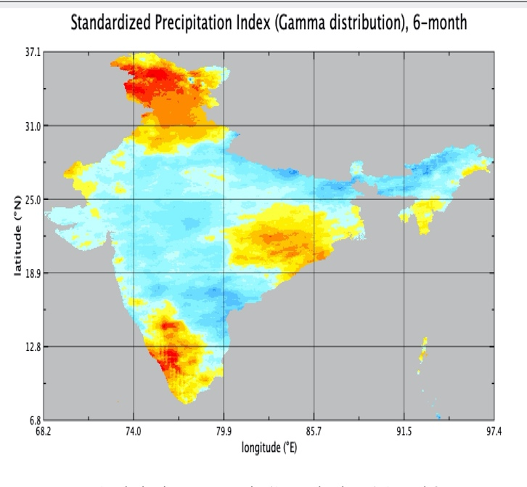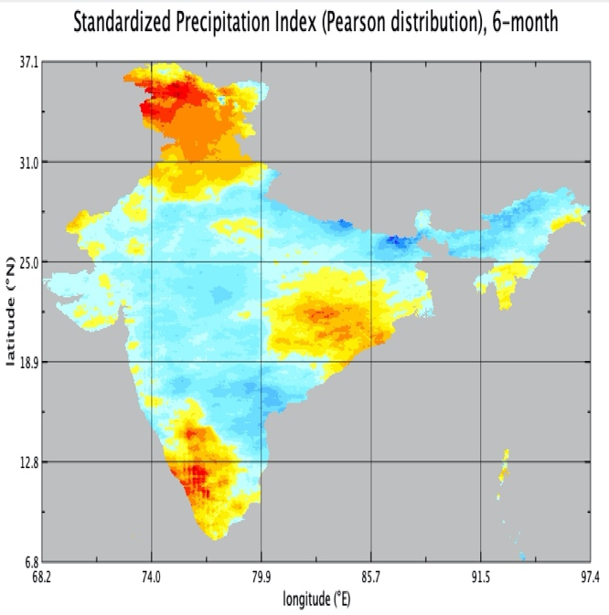

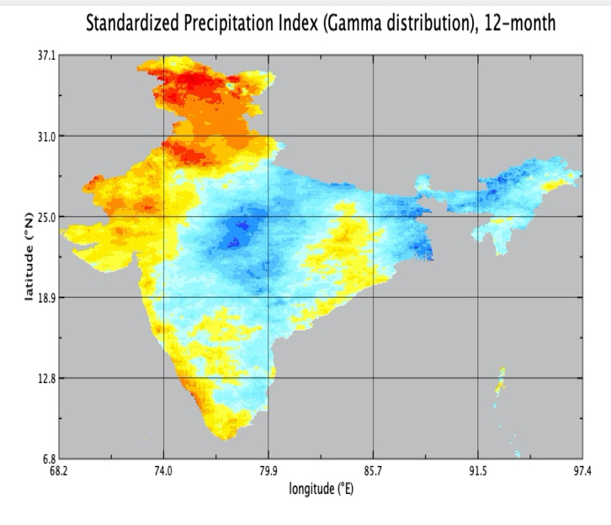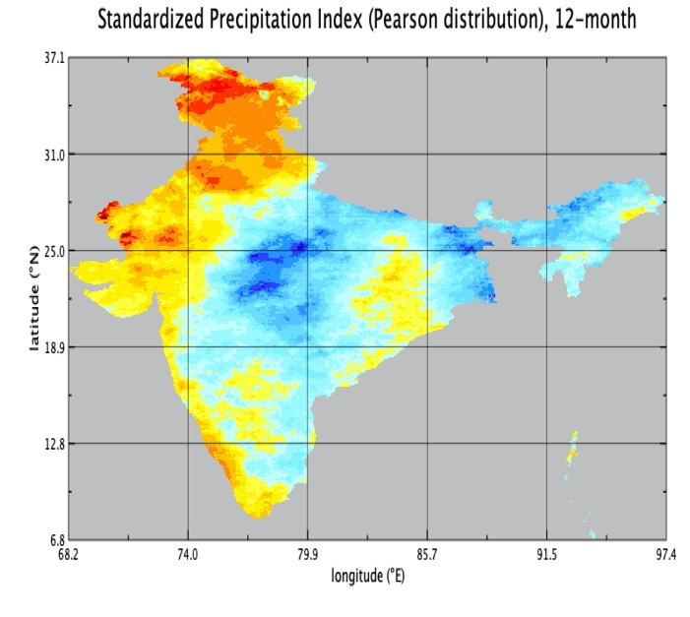

**SPI computations for India**

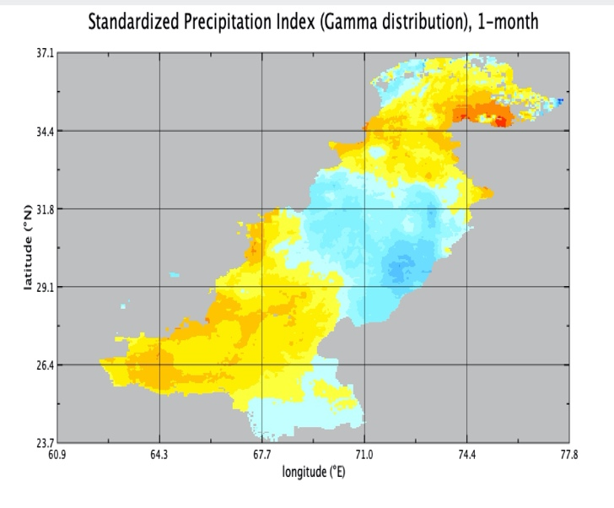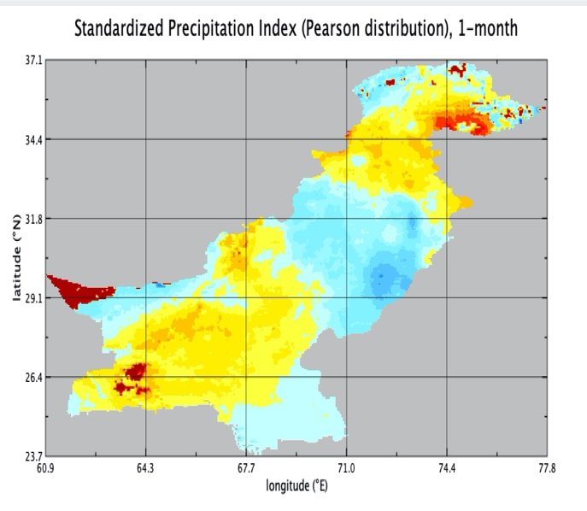

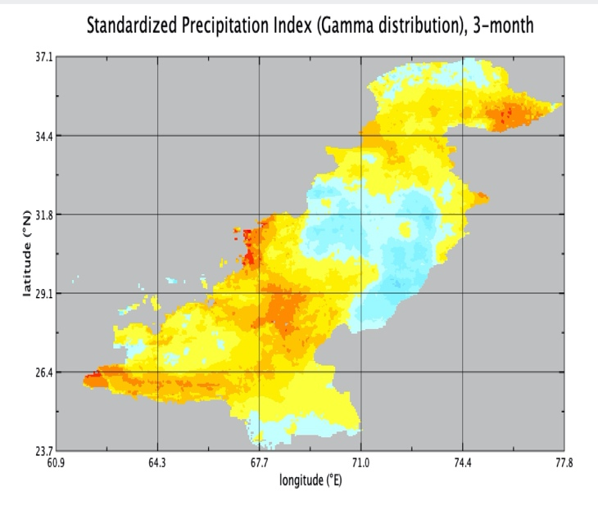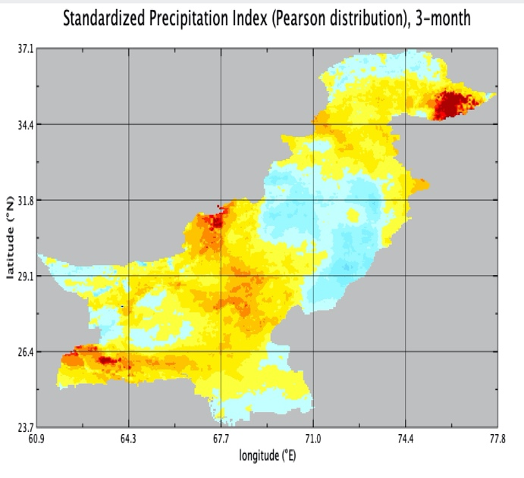

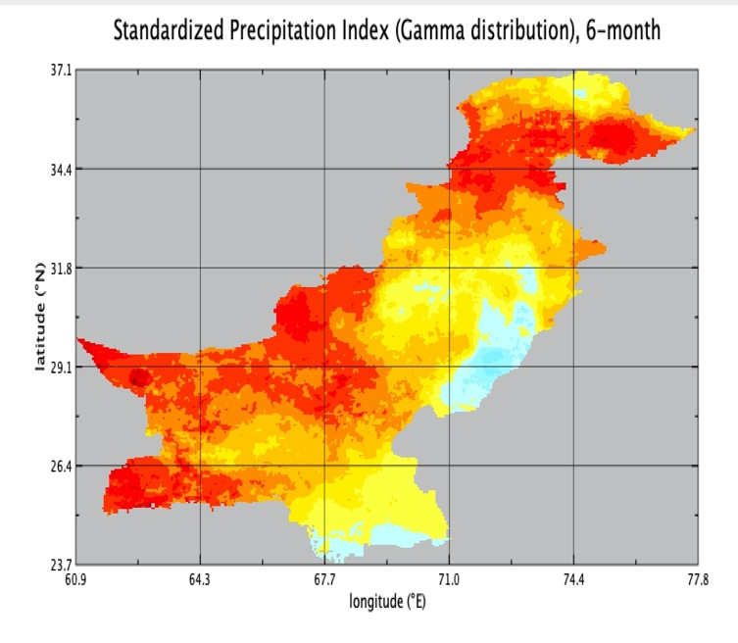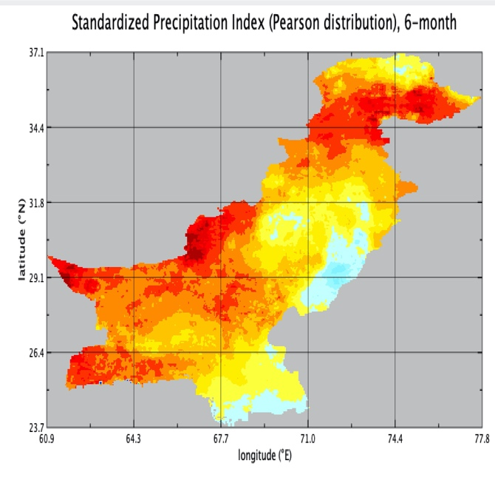

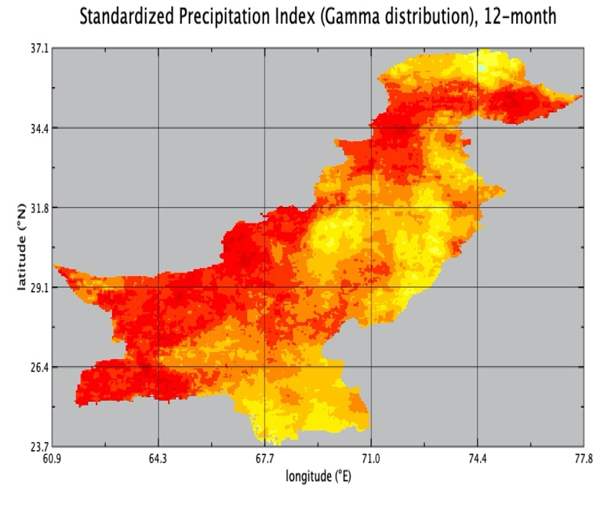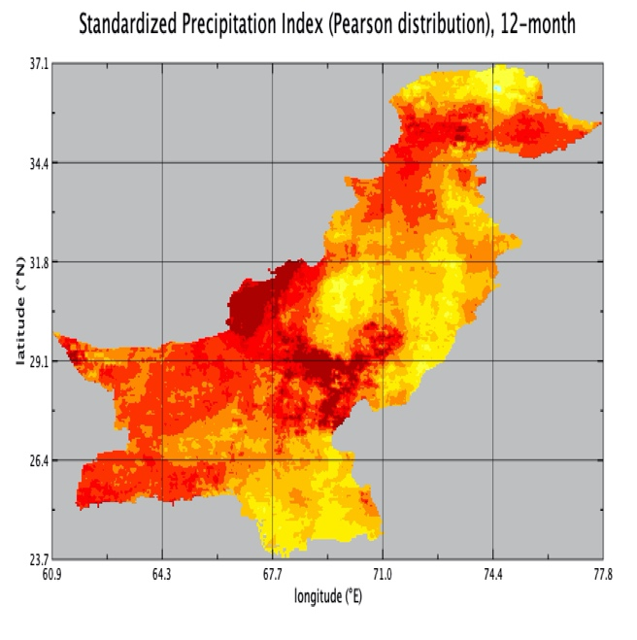

**SPI computations for Pakistan**

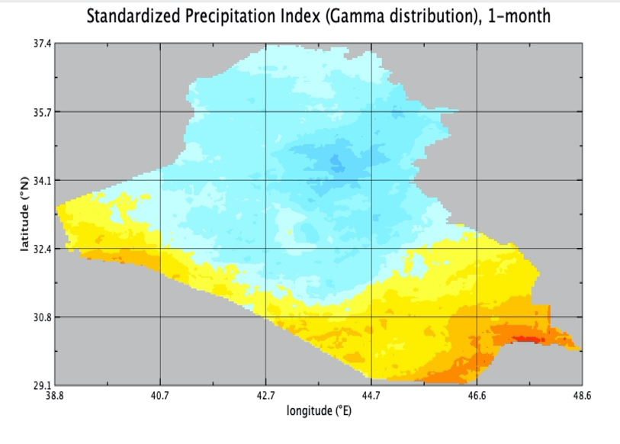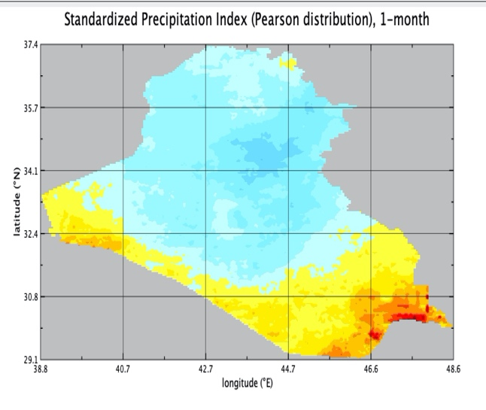

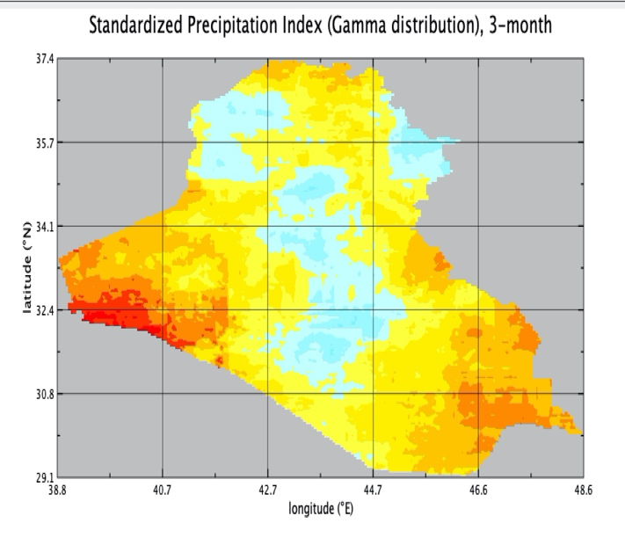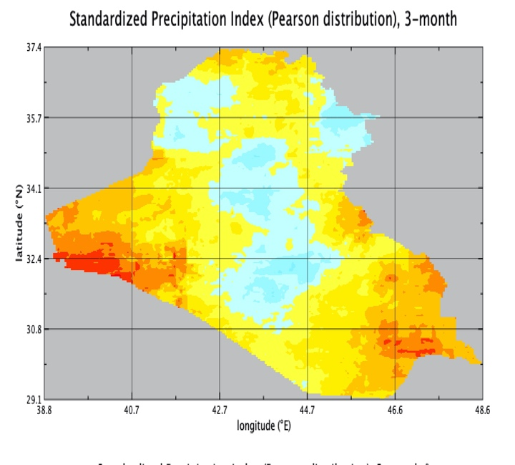

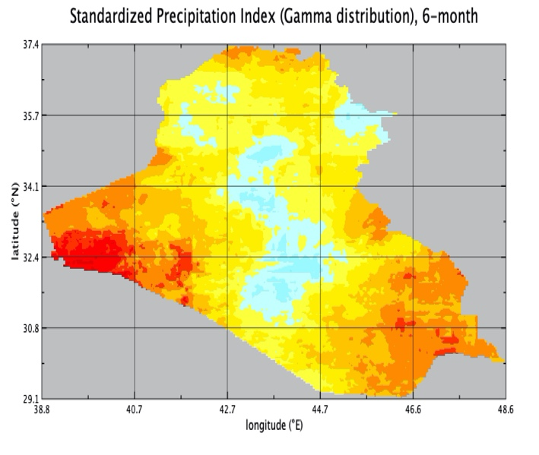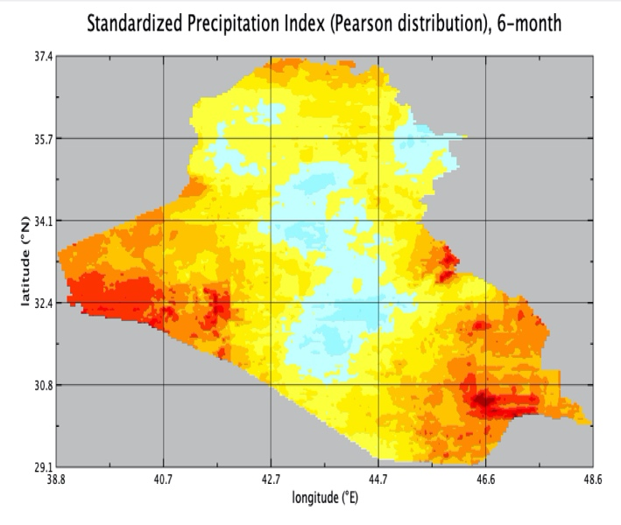

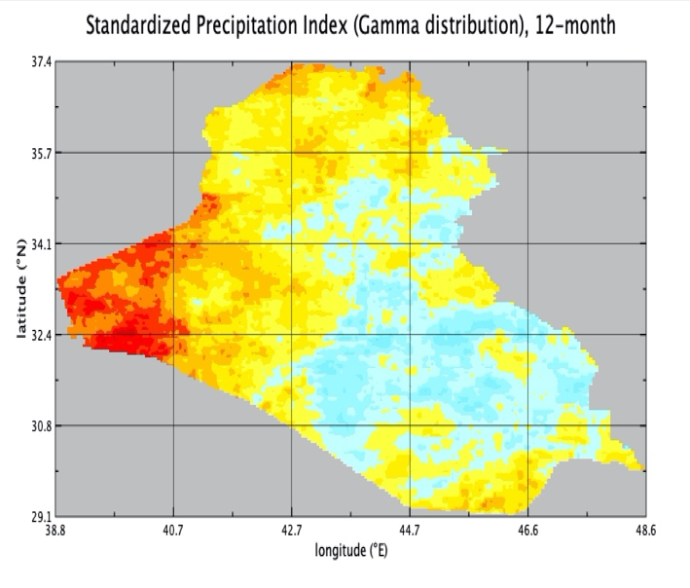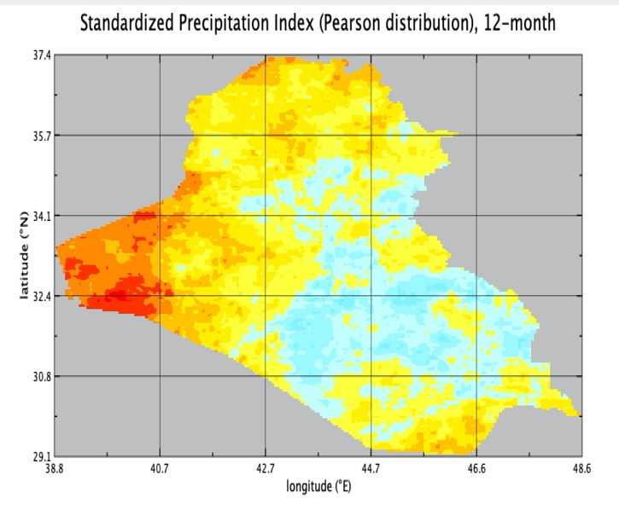

**SPI computations for Iraq**

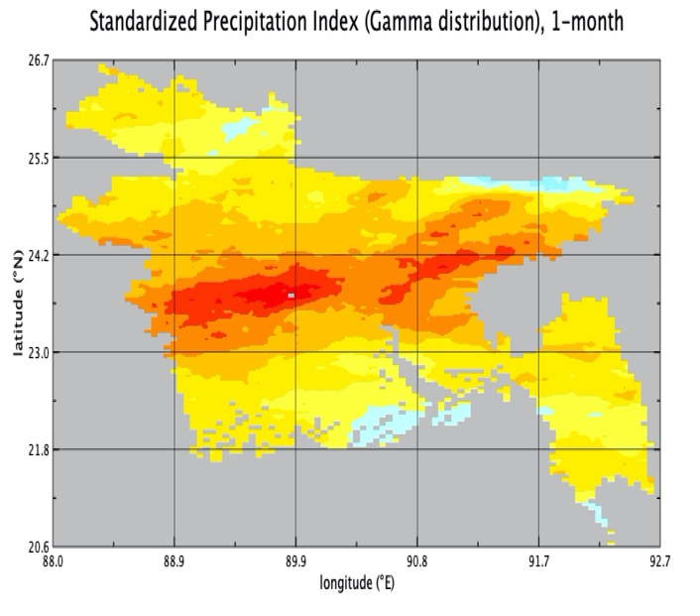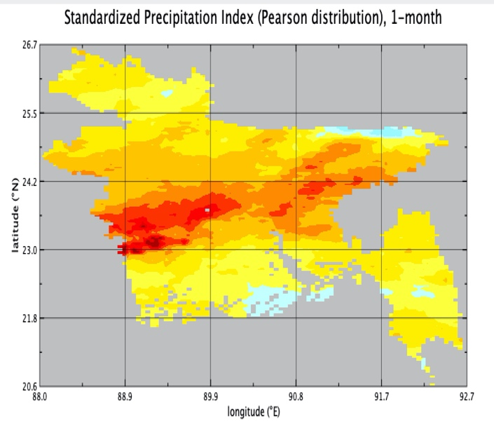

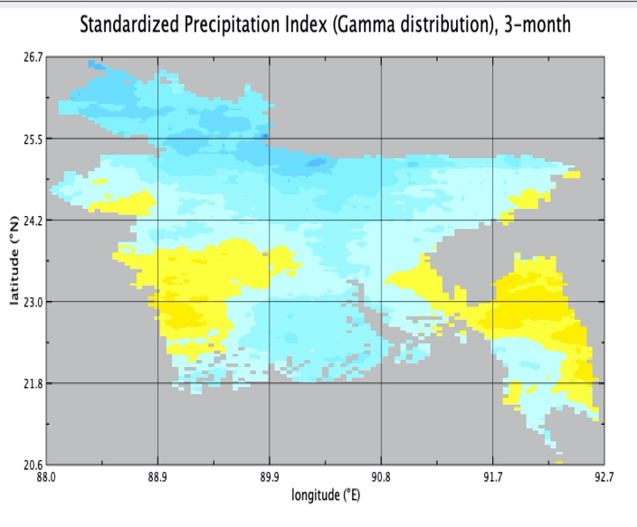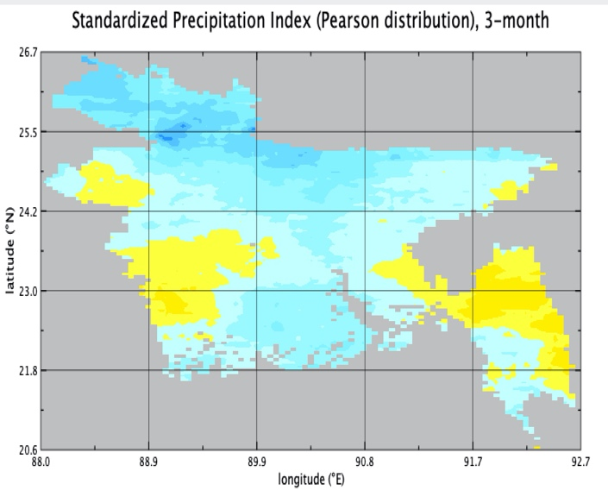

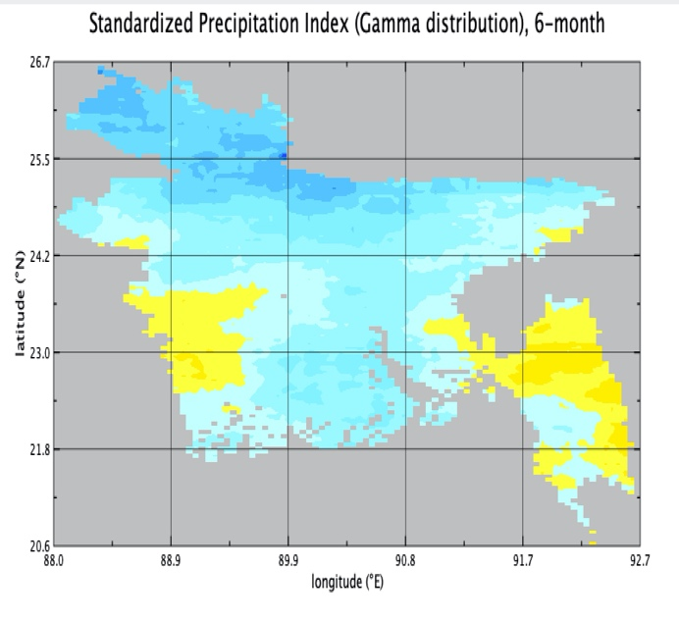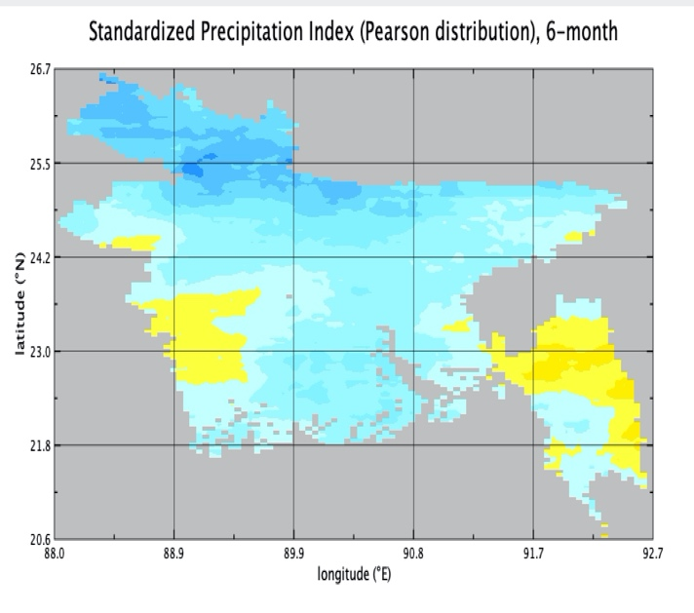

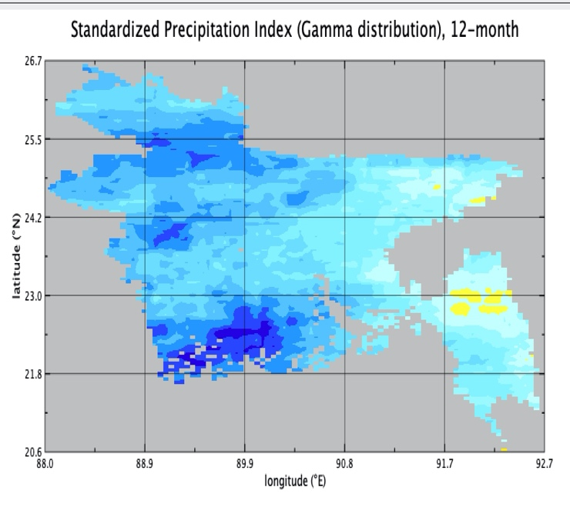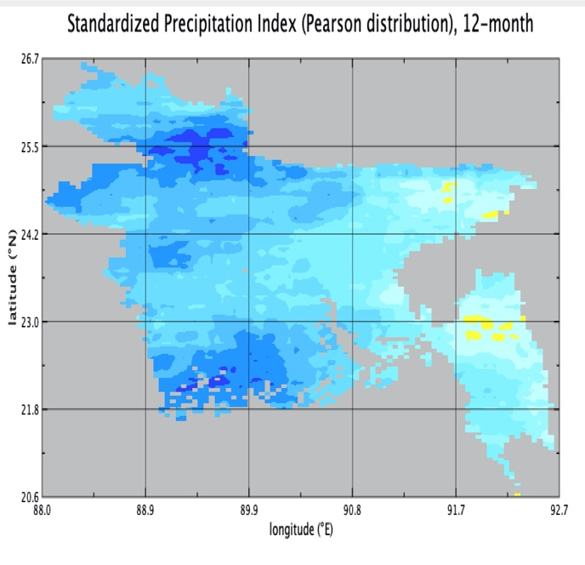

**SPI Computations for Bangladesh**

**4. Conclusions and Future work**

**4.1 Conclusions**

The SPI is characterized by technical credibility, policy relevance, and technical adequacy (Karavitis et al., 2011), it brings essential benefits to the drought investigators, like simplicity and flexibility. Overall, SPI described well the drought conditions in all the four countries. The spatial visualization provided an oriented tool for immediate drought classification. Also, its probability-based nature (probability of observed precipitation transformed into an index) makes it well suited to risk management and triggers for decision-making.

**4.2 Future work**

* Analyzing zeros in the precipitation data
* Handling missing values and noise in the data

**5. References**

Abramowitz M, Stegun IA (eds). 1965. Handbook of Mathematical

Formulas, Graphs, and Mathematical Tables. Dover Publications:

New York.

Abramowitz M, Stegun IA (eds). 1965. Handbook of Mathematical

Formulas, Graphs, and Mathematical Tables. Dover Publications:

New York.

Abramowitz M, Stegun IA (eds). 1965. Handbook of Mathematical

Formulas, Graphs, and Mathematical Tables. Dover Publications:

New York.

Abramowitz M, Stegun IA (eds). 1965. Handbook of Mathematical

Formulas, Graphs, and Mathematical Tables. Dover Publications:

New York.

Abramowitz M, Stegun IA (eds). 1965. Handbook of Mathematical

Formulas, Graphs, and Mathematical Tables. Dover Publications:

New York.

Abramowitz M, Stegun IA (eds). 1965. Handbook of Mathematical

Formulas, Graphs, and Mathematical Tables. Dover Publications:

New York.

Abramowitz M, Stegun IA (eds). 1965. Handbook of Mathematical

Formulas, Graphs, and Mathematical Tables. Dover Publications:

New York.

Abramowitz M, Stegun IA (eds). 1965. Handbook of Mathematical

Formulas, Graphs, and Mathematical Tables. Dover Publications:

New York.

Abramowitz M, Stegun IA (eds). 1965. Handbook of Mathematical

Formulas, Graphs, and Mathematical Tables. Dover Publications:

New York.

Abramowitz M, Stegun IA (eds). 1965. Handbook of Mathematical

Formulas, Graphs, and Mathematical Tables. Dover Publications:

New York.

Abramowitz M, Stegun IA (eds). 1965. Handbook of Mathematical

Formulas, Graphs, and Mathematical Tables. Dover Publications:

New York

Abramowitz M, Stegun IA (eds). 1965. Handbook of Mathematical Formulas, Graphs, and Mathematical Tables. Dover Publications: New York

Cheval, Sorin. (2015). The Standardized Precipitation Index – an overview. Romanian Journal of Meteorology. 12. 17-64.

Guttman NB. 1999. Accepting the Standardized Precipitation Index: A calculation algorithm. Journal of the American Water Resources Association 35: 311–322

James Adams. (2017). climate_indices, an open source Python library providing reference implementations of commonly used climate indices. Link: (https://github.com/monocongo/climate_indices)

Murthy, C. & Seshasai, Mullapudi & Roy, Parth. (2009). On the use of Standardized Precipitation Index (SPI) for drought intensity assessment. Meteorological Applications. 16. 381-389.

McKee, T.B., N.J. Doesken and J. Kleist, 1993: The relationship of drought frequency and duration to time scale. In: Proceedings of the Eighth Conference on Applied Climatology, Anaheim, California,17–22 January 1993. Boston, American Meteorological Society, 179–184.

Salehnia, Nasrin & Alizadeh, Amin & Sanaeinejad, Hossein & Bannayan, Mohammad & Zarrin, Azar & Hoogenboom, Gerrit. (2017). Estimation of meteorological drought indices based on AgMERRA precipitation data and station-observed precipitation data. Journal of Arid Land, 9(6): 797-809. Link: [https://doi.org/10.1007/s40333-017-0070-y](http://www.wamis.org/agm/pubs/SPI/WMO_1090_EN.pdf)

World Meteorological Organization, 2012: Standardized Precipitation Index User Guide (M. Svoboda, M. Hayes, and D. Wood). (WMO-No. 1090), Geneva.

Link: <http://www.wamis.org/agm/pubs/SPI/WMO_1090_EN.pdf>

**Additional Materials**

* QGIS (<https://www.qgis.org/en/site/>)
* GDAL (<https://gdal.org/>)
* Precipitation Data CHRIPS: (<ftp://ftp.chg.ucsb.edu/pub/org/chg/products/CHIRPS-2.0/global_daily/tifs/p05/>)
* Shape Files: (<https://data.humdata.org/>)
* Climate Indices (<https://github.com/monocongo/climate_indices>)